# Software Development SAT – James Bouwmeester

File management

As seen in the image below, my file structure was semantically named to ensure clear identification of what each file was. No CSS folder was created, as only one stylesheet was used alongside the Bootstrap styling. Folders including source files from the web, Bootstrap and Fontawesome (used for icons), included the version of the files. This ensured that I knew what version of these files I was using, allowing me to download and implement newer releases if necessary. Moreover, snippets of code used across many pages were included in the *templates* folder so they could be kept separate to the pages of the solution.

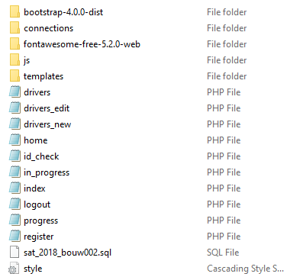

File structure

These files were stored on my local sever, however, weekly backups were made to an external hard drive and to my OneDrive file structure, this ensured that an online copy of my solution was always accessible. When backed up to an external hard drive, the date of the backup was included, which provided version control as I had a record of the changes made to the program as well as the dates these were made. In the case of a major error, this allowed me to restore my program to the most previous working state and hopefully not lose much progress.

All data collected by the program will be stored in a mySQL database. This data structure allows for easy addition, changing and retrieval of data through various insert, update and query strings. Moreover, forms containing sensitive data such as passwords used the post method of form submission so as to prevent this data from appearing in the page URL. Additionally, passwords were hashed before being stored into the database using the php *password_hash* function. When logging in, the entered password was compared to the stored password using the *password_verify* function, meaning at no point is the user’s password visible.